Support Vector Regression based Modeling of Pier Scour using Field Data

Mahesh Pal N. K. Singh² and N. K. Tiwari ³
Abstract: This paper investigates the potential of support vector machines based regression approach to model the local scour around bridge piers using field data. A dataset of consisting of 232 pier scour measurements taken from BSDMS were used for this analysis. Results obtained by using radial basis function and polynomial kernel based Support vector regression were compared with four empirical relation as well as with a backpropagation neural network and generalized regression neural network. A total of 154 data were used for training different algorithms whereas remaining 78 data were used to test the created model. A coefficient of determination value of 0.897 (root mean square error = 0.356) was achieved by radial basis kernel based support vector regression in comparison to 0.880 and 0.835 (root mean square error = 0.388 and 0.438) by backpropagation neural and generalized regression neural network. Comparisons of results with four predictive equations suggest an improved performance by support vector regression. Results with dimensionless data using all three algorithms suggest a better performance by dimensional data with this dataset. Sensitivity analysis suggests the importance of depth of flow and pier width in predicting the scour depth when using support vector regression based modeling approach.
Keywords: pier scour, field scour data, support vector machines, Froehlich equation, HEC18 equation, neural network.

Introduction

Scour is a natural phenomenon caused by the removal of sediments near the structures by the action of turbulent flow. The scour reduces the bed elevation near the piers and abutments thus exposing the foundations of a bridge, which may results in structural collapse as well as loss of life and property. The amount of this reduction below an assumed natured level is termed scour depth. Failure of bridges due to scour at abutments and piers is a common occurrence. Bridge scour is a function of flow energy, sediment-transport characteristics, and bridge characteristics.
Richardson and Davis (2001) suggested that total scour at a bridge can be divided into aggradation or degradation, contraction scour and local scour. Local scour is defined as the removal of bed material from around piers, abutments, spurs, and embankments. Local scour can either be clear-water or live-bed. Local scour at piers is caused by the formation of vortices known as the horseshoe vortex at their base. The horseshoe vortex is caused by the accumulation of water on the upstream surface of the obstruction resulting in increased shear stress and hence an increase in sediment transport capacity of the flow. This acceleration in sediment transport capacity of flow removes bed material from around the base of the pier. Thus, the amount of the sediments carried away from the base region is greater than the amount being brought into the region, consequently, causing a scour hole around the bridge pier. The temporal variation of scour and the maximum depth of scour at bridge pier mainly depend on the characteristics of flow, pier and river-bed material. Accurate estimation of equilibrium depths of local scour around bridge piers is a vital issue in the hydraulic design of bridges.
Accurate measurement of equilibrium depths of local scour around bridge piers is a vital issue in the design of bridges concerned to the hydraulics engineering. Equilibrium scour occurs when the scour depth does not change appreciably with time or scouring rate becomes insignificant. Equilibrium between the erosive capability of the flow and the resistance to motion of the bed materials is progressively attained through erosion of the flow boundary. The physical process of scour around bridge piers is quite complicated which makes the development of methodology for predicting scour at bridge piers difficult.
Most of the researches in the field of local scour at bridge piers are based on dimensional analysis using small-scale laboratory experiments with non-cohesive and cohesive uniform bed material under steady-flow conditions (Kandasamy and Melville, 1998; Ansari et. al., 2002). A number of equations are proposed to estimate local scour at bridges by carrying out laboratory experiments (McIntosh, 1989; Mueller and Wagner, 2005). The equations developed using laboratory research have not been adequately verified by using field data and the scour prediction methods developed based on laboratory data did not always produce good results for field conditions (Melville, 1975; Dargahi, 1982; Jones, 1984). Due to scale effect, laboratory settings oversimplify or ignore the complexities of natural rivers and majority of researches are conducted with uniform flow, a constant depth of flow and non-cohesive bed materials, thus the scour-depth equations based on laboratory flume data were found to overestimate scour depth measured at bridge piers (Mueller and Wagner, 2005).
Soft computing technique, like artificial neural network is being used in prediction of scour (Trent et al., 1993; Trent et al., 1999; Kambekar and Deo 2003; Choi and Cheong, 2006; Azmathullah et al., 2006; Bateni et al. 2007; Bateni et al. 2007; Ayoubloo et al., 2010; Kaya, 2010) and their performance was compared with different empirical equations. Most of these studies suggest that neural network approach works well in comparison to the empirical relations. A neural network based modeling algorithm requires setting up of different learning parameters (like learning rate, momentum), the optimal number of nodes in the hidden layer and the number of hidden layers. A large number of training iterations may force a neural network to overtrain, which may affect the predicting capabilities of the model. Further, presence of local minima is another problem with the use of a back propagation neural network. Recent studies by Guven and Gunal (2008), Guven et al., (2009) and Azamathulla et al. (2010) suggest the usefulness of genetic algorithm to find the optimal architecture of a neural network for scour prediction.
Within last decade, several studies reported the use of generalized regression neural network and support vector machines in civil engineering (Abu Keifa, 1998; Nawai et al., 1999; Dibike et al., 2001; Pal and Mather, 2003; Cigizoglu, 2005; Kurup and Griffin, 2006; Gill et al., 2006; Pal and Goel, 2006; Pal, 2006; Pal and Deswal, 2008; Firat and Gungor, 2008; Pal and Goel, 2009; Pal and Singh, 2010) and found them working well in comparison to a back propagation neural network approach. The advantage of using a generalized regression neural network and support vector machines is that both of these approaches require few user-defined parameters and do not face the problem of local minima.
Keeping in view the improved performance by support vector machine based regression approach in civil engineering problems; this study compare its performance with four empirical relations, a backpropagation neural network and a generalized regression neural network in modeling pier scour. A study by Mueller and Wagner, (2005) suggests that out of 26 equations used in their study no single equation is conclusively better than the rest. Thus, four empirical relations (HEC-18, HEC-18/Mueller equation, Froehlich, 1988; Froehlich Design 1988) were used to compare their performance with support vector machines based regression.

Data set

Of the total 493 pier scour measurements available in the bridge scour data management system (Mueller and Wagner, 2005), 232 data for upstream scour were selected for this study. The time required for scour to reach its maximum depth in cohesive material is considerably longer than in non-cohesive material. Therefore, observations with scour in cohesive material (a total of 5 data out of 493 measurements) were removed from this analysis. Data sets with pier type “group”, “unknown bed material”, “missing value of any input variable” and having “zero scour” (a total of six data for zero scour with non-cohesive material) were also removed from the total data set. Furthermore, data sets with scour measurements at the downstream side of piers were also removed. The effect of debris on the scour depth was also provided in the data set and grouped in four categories (i.e. unknown, insignificant, moderate and substantial). Debris accumulation near a pier often makes measurement of maximum scour impossible and may increase the scour near the pier due to a larger obstruction to flow (Song et al., 1989). Thus, all scour measurements with “substantial” and “moderate” effect of debris (a total of 40 data, having 14 data with scour measurement at the downstream side and 3 data with pier type group) were removed from the data set. Finally, the remaining dataset was divided randomly in a way such that 154 data were used for training purposes and the remaining 78 data to test the models.
Seven input parameters namely pier shape factor (Ps), pier width (Pw), skew of the pier to approach flow (skew), velocity of the flow (V), depth of flow (h), D₅₀ (i.e. the grain size of bed material in mm for which 50 percent is finer) and gradation of bed material () were used to predict the scour depth. Minimum, maximum, mean and standard deviation values of all input and output parameters used in this study are provided in table 1.
Insert table 1 here

Support Vector Machines (SVM)

Support vector machines are classification and regression methods which have been derived from statistical learning theory (Vapnik, 1995). The SVM classification methods are based on the principle of optimal separation of classes. If the classes are separable, this method selects, from among the infinite number of linear classifiers, the one that minimizes the generalization error or at least an upper bound on this error, derived from structural risk minimization (Vapnik, 1995). Thus, the selected hyperplane would be one that leaves the maximum margin between the two classes, where margin is defined as the sum of the distances of the hyperplane from the closest point of the two classes (Vapnik, 1995).
If the two classes are non-separable, SVM tries to find the hyperplane that maximizes the margin and that, at the same time, minimizes a quantity proportional to the number of misclassification errors. The trade off between margin and misclassification error is controlled by a positive constant that has to be chosen beforehand. This technique of designing an SVM can be extended to allow for non-linear decision surfaces. This can be achieved by projecting the original set of variables into a higher dimensional feature space and formulating a linear classification problem in the feature space (Vapnik, 1995).
Vapnik (1995) proposed -Support Vector Regression (SVR) by introducing an alternative -insensitive loss function. The purpose of the SVR is to find a function having at most deviation from the actual target vectors for all given training data and have to be as flat as possible (Smola, 1996). Vapnik (1995) introduced the concept of kernel function for non-linear support vector regression. For further details of support vector regression, readers are referred to Smola (1996) and Vapnik (1995).
SVR requires setting of fewer user-defined parameters. In addition to the choice of a kernel, SVR requires the setting up of kernel specific parameters. Further, the optimum values of the regularization parameter C and the size of error in sensitive zone ε need to be determined. The choice of these parameters controls the complexity of prediction. One major advantage of SVR is its optimization algorithm, which includes solving a linearly constrained quadratic programming function leading to a unique, optimal, and global solution.

Artificial Neural Network (NN)

Neural networks are general-purpose computing tools that can solve complex non-linear problems. The network comprises a large number of simple processing elements linked to each other by weighted connections according to a specified architecture. These networks learn from the training data by adjusting the connection weights (Bishop, 1995). The basic element of a back-propagation neural network is the processing node. Each processing node behaves like a biological neuron and performs two functions. First, it sums the values of its inputs. This sum is then passed through an activation function to generate an output. Any differentiable function can be used as activation function. All the processing nodes are arranged into layers, each fully interconnected to the following layer. There is no interconnection between the nodes of the same layer. In a back propagation neural network, generally, there is an input layer that acts as a distribution structure for the data being presented to the network. This layer is not used for any type of processing. After this layer, one or more processing layers follow, called the hidden layers. The final processing layer is called the output layer.
The values of the interconnecting weights are not set by the analyst but determined by the network during the training process, starting with randomly assigned initial weights. There are a number of algorithms that can be used to adjust the interconnecting weights to achieve minimal overall training error in multi-layer networks (Bishop, 1995). The generalized delta rule, or back-propagation is one of the most commonly used methods. This method uses an iterative process to minimize an error function over the network output and a set of target outputs, taken from the training data set. The goal of training is to minimize the overall error difference between the desired and the actual outputs of the network. The process of training begins with the entry of the training data to the network. These data flow forward through the network to the output units. At this stage, the network error, which is the difference between the desired and actual network output, is computed. This error is then fed backwards through the network towards the input layer with the weights connecting the units being changed in relation to the magnitude of the error. This process is repeated until the error rate is minimized or reaches an acceptable level, or until a specified number of iterations has been accomplished.

Generalized regression neural network

The Generalized Regression Neural Network (GRNN) proposed by Specht (1991), is a normalized radial basis function (RBF) network in which there is a hidden unit centered at every training example. These RBF units are called "kernels" and are usually probability density functions such as the Gaussian. The hidden-to-output weights are just the target values, so the output is simply a weighted average of the target values of training cases close to the given input case. The only weights that need to be learned are the widths of the RBF units. The GRNN does not require an iterative training procedure as in the back-propagation method. A GRNN configuration consists of four layers. The input units are in the first layer, the second layer has the pattern units, the outputs of this layer are passed on to the summation units in the third layer, and the final layer covers the output units. The first layer is fully connected to the second, pattern layer, where each unit represents a training pattern and its output is a measure of the distance of the input from the stored patterns. The optimal value of user-defined parameter called spread (s) is determined experimentally. For further details of the GRNN readers are referred to Specht (1991) and Wasserman (1993).

Details of algorithms

In situations with non-linear decision surfaces, SVR use the concept of the kernel function (Vapnik, 1995). A number of kernels are discussed in the literature, but studies suggest a better performance by polynomial and radial basis kernels for different civil engineering problems (Pal and Mather, 2003; Pal and Goel, 2006; Gill et al., 2006). Present study uses a polynomial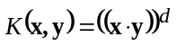and a radial basis kernel (RBF) (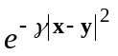), where d and are kernel specific parameters.
The SVR, in addition to the choice of a kernel requires setting up of kernel specific parameters, optimum values of the regularization parameter C and the size of the error-insensitive zone. For this study, default value of (i.e. 0.0010) was found working well. To select user-defined parameters (i.e., C, d and), a large number of trials were carried out by using different combination of C and d for polynomial kernel and C and γ for radial basis function kernel.
Similarly, a large number of trial were also carried out to find out the user defined parameters (i.e. number of hidden layers and nodes in hidden layer, learning rate, momentum and the number of iterations)for backpropagation neural network. Results suggest that one hidden layer works well with this data. Table 2 provides the optimal values of user-defined parameters for this dataset with polynomial and RBF kernel based SVR as well as with backpropagation neural network. For fair comparison of results with both RBF and polynomial kernels, same value of parameter C was used with SVR. In present study, SVR_poly and SVR_rbf represent polynomial and RBF kernel based SVR where as NN represents the backpropagation neural network. SVR and back propagation neural network algorithms as implemented by Witten and Frank (2005) were used.
Insert Table 2 here

Results
Coefficient of determination (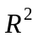) and root mean square error (RMSE) were used to compare the performance of SVR with empirical relations and neural network models. Table 3 provides the value of coefficient of determination and RMSE obtained by radial basis function and polynomial kernel based SVR. Coefficient of determination value of 0.897 and 0.850 (RMSE = 0.356 m and 0.426 m) was achieved by the RBF and polynomial kernel based SVR respectively. A higher value of Coefficient of determination with RBF kernel confirms that this kernel works well in comparison to polynomial kernel in predicting the scour depth by SVR.
Insert Table 3 here
Figure 1 provide the graph plotted between actual and predicted value of scour depth obtained by using RBF and polynomial kernel based SVR with the test dataset. This figure suggests that most of the predicted values are lying within ±25% error from the line of perfect agreement with RBF kernel based SVR.
Insert Figure 1 here
Optimal value of user-defined parameters of NN is provided in table 2. For GRNN, only one parameter i.e. spread of radial basis functions need to be determined for a given dataset. After a large number of trials, a value of 0.62 was found working well with this dataset. A coefficient of determination value of 0.880 and 0.835 (RMSE = 0.388 m and 0.438 m) was achieved using the NN and GRNN respectively. A comparison of results with RBF based SVR suggests an improved performance by this approach in comparison to both NN and GRNN in predicting the scour depth for the dataset considered in this study. Results in terms of coefficient of determination and RMSE suggest a better performance by NN algorithm in comparison to the GRNN. Plot of actual and predicted scour depth by both NN and GRNN (Table 1) also suggests effectiveness of RBF kernel based SVR in predicting the scour depth in comparison to both neural network approaches.
The same data set was used to compare SVR performance with four empirical relations in predicting the scour depth (Table 4). A comparison of coefficient of determination and RMSE values (Tables 3 and 4) indicates that SVR based modeling approach provides improved predictions of scour depth in comparison to all four empirical relations. Results also suggest a better performance by NN and GRNN in comparison to the empirical relations. Figure 2 provides a graph between actual and predicted values of scour depth using Froehlich Equation (1988), Froehlich Design (1988), HEC-18 and HEC-18/Mueller equations. Figure 2 and table 4 suggests that Froehlich Design (1988) perform well in comparison to other three empirical relations with the dataset used in this study. Of the four empirical relations used in this study, Froehlich (1988) under-predicts most of the values whereas the remaining three equations over-predict the scour depth. The poor performance of HEC-18 may be due to the reason that the equation is deliberately designed to provide conservative estimate of scour prediction.
Insert Table 4 here
Insert Figure 2 here
In order to predict the normalized scour depth (scour/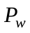), seven input parameters were reduced to six non-dimensional parameters (i.e.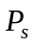, skew angle,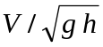, 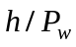,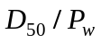and ). The same dataset consisting of 154 data for training and 78 for testing were used with RBF kernel based SVR, NN and GRNN. Table 1 indicates no significant difference between the statistics of the training and test non-dimensional data. In order to have a fair comparison, same value of user-defined parameters as used with dimensioned data were used. To have consistent results, predicted normalized scour depth was converted to scour depth and appropriate statistical measures were re-calculated. A coefficient of determination value of 0.782, 0.728 and 0.531 (RMSE = 0.522, 0.580, 0.729) was achieved with RBF based SVR, NN and GRNN respectively. Comparison of coefficient of determination and RMSE values with dimensional and non-dimensional inputs suggest a better performance by dimensional input based modeling approach with the dataset used in this study. Figure 3 provide a plot between actual and predicted values of scour obtained by using RBF based SVR, NN and GRNN with non-dimensional inputs. This figure suggests that a majority of the predicted values are lying outside the ±25% lines, a possible reason for the higher value of RMSE and lower value of coefficient of determination with this dataset.
Insert Figure 3 here

Sensitivity analysis

Sensitivity tests were conducted using RBF based SVR to determine the relative significance of each of the input parameters on the scour depth. Several factors affect the magnitude of local scour depth at piers. These includes pier width, pier shape, flow depth, approach velocity and bed material characteristics (Richardson and Davis, 2001). Various input combinations as provided in Table 5 were considered by removing one input variable in each case and its influence on predicted scour was evaluated in terms of the root mean square error and coefficient of determination as main performance criteria. Table 5 compares the performance of RBF kernel based SVR model with different input combinations using same user-defined parameters as provided in table 2. Results from table 5 suggest that the approach depth of flow and pier width has major influence in predicting the local scour with SVR in comparison to other input parameters and removing any other input parameter have no major influence on the predicting capability of SVR. Mueller and Wagner (2005) also reported varying influence of velocity of flow in comparison to pier width and approach depth of flow in predicting the pier scour using weighted and unweighted regression with BSDMS dataset. The results also suggest that RBF based SVR provide best performance with data combination involving pier shape factor, pier width, skew of the pier to approach flow, approach depth of flow, velocity of the flow and gradation of bed material.
Insert table 5 here

Conclusions

This paper investigate the potential of SVR in predicting the local scour using the field data in comparison to NN, GRNN and four empirical relations. A major conclusion from this study is that radial basis kernel based SVR approach works well in predicting the pier scour depth in comparison to all four empirical relations. Results also suggest an improved performance by RBF based SVR in comparison to both NN and GRNN based approaches whereas NN perform well in comparison to GRNN with this dataset. A comparison of results with non-dimensional input parameters suggests a better performance by dimensional input parameters with this dataset. Finally, results suggest that approach depth of flow and the pier width are two important parameters affecting the scour prediction using RBF based SVR with the dataset used in this study.
References
Ansari, S. A., Kothyari, U. C., Ranga Raju, K. G., 2002. Influence of cohesion on scour around bridge piers. Journal of Hydraulic Research, IAHR, 40(6), 717–729.
Abu Keifa, M. A., 1998. General regression neural networks for driven piles in cohesionless soil. Journal of Geotechnical and Geoenvironmental Engineering, 124(12), 1177-1185.
Azmathullah H.M., Deo M.C. and Deolalikar P.B., 2006. Estimation of scour below spillway using neural networks, Journal of Hydraulic Research, IAHR, 44(1), 61-69.
Azamathulla, H. Md., Ghani, A. Ab., Zakaria N. A. and Guven, A., 2010. Genetic programming to predict bridge pier scour. Journal of Hydraulic Engineering, ASCE, 136, 165-169.
Ayoubloo, M. K., Etemad-Shahidi, A. and Mahjoobi, J., 2010. Evaluation of regular wave scour around a circular pile using data mining approaches, Applied Ocean Research, 32, 34-39.
Bishop, C. M., 1995. Neural networks for pattern recognition. Oxford: Clarendon Press.
Bateni, S. M., Jeng, D.-S., and Melville, B. W., 2007. Bayesian neural networks for prediction of equilibrium and time-dependent scour depth around bridge piers, Advances in Engineering Software, 38, 102–111.
Bateni, S. M., Borghei, S.M. and Jeng, D.-S., 2007. Neural network and neuro-fuzzy assessments for scour depth around bridge piers. Engineering Applications of Artificial Intelligence, 20, 401–414.
Cigizoglu, H. K., 2005. Application of generalized regression neural networks to intermittent flow forecasting and estimation. Journal of Hydrologic Engineering, 10, 336–341.
Choi, S.-U. and Cheong, S. 2006. Prediction of local scour around bridge piers using artificial neural networks. Journal of American Water Resources Association, 42,487-494.
Dibike, Y. B., Velickov, S., Solomatine, D. P. and Abbott, M. B., 2001. Model induction with support vector machines: Introduction and applications, Journal of Computing in Civil Engineering, 15, 208-216.
Dargahi, B., 1990. Controlling mechanism of local scouring. Journal of Hydrologic Engineering, 116(10), 1197-1214.
Froehlich, D.C., 1988. Analysis of onsite measurements of scour at piers, In American Society of Civil Engineers National Conference on Hydraulic Engineering: Colorado Springs, CO, American Society of Civil Engineers, p. 534–539.
Firat, M. and Gungor, M., 2009. Generalized Regression Neural Networks and Feed Forward Neural Networks for prediction of scour depth around bridge piers, Advances in Engineering Software, 40(8), 731-737.
Goel, A. and Pal, M., 2009. Application of support vector machines in scour prediction on grade-control structures, Engineering Applications of Artificial Intelligence, 22(2), 216-223.
Gill, M.K., Asefa, T., Kemblowski, M. W. and Makee, M., 2006. Soil moisture prediction using Support Vector Machines. Journal of the American water resources association, 42, 1033-1046.
Guven, A. Azamathulla, H. Md. And Zakaria, N.A., 2009. Linear genetic programming for prediction of circular pile scour, Ocean Engineering, 36(12-13), 985-991.
Guven, A. and Gunal, M., 2008. Prediction of local scour downstream of grade-control structures using neural networks. Journal of Hydraulic Engineering, ASCE, 134, 1656-1660.
Jones, J.S., 1984. Comparison of prediction equations for bridge pier and abutment scour. Trans. Res. Rec. 1950, Transportation Research Board, Washington.
Kandasamy, J.K. and Melville, B.W., 1998. Maximum local scour depth at bridge piers and abutments. Journal of Hydraulic Research, IAHR, 36(2), 183-198.
Kambekar, A.R., Deo, M.C., 2003. Estimation of group pile scour using neural networks. Journal of Applied Ocean Research, 25(4), 225-234.
Kaya, A., 2010. Artificial neural network study of observed pattern of scour depth around bridge piers, Computers and Geotechnics, 37(3), 413-418.
Kurup, P. U. and Griffin, E. P., 2006. Prediction of soil composition from CPT data using general regression neural network. Journal of Computing in Civil Engineering, 20(4), 281–289.
Melville, B.W., 1975. Local scour at bridge sites. University of Auckland, School of Engineering, Auckland, New Zealand, Rep. No. 117.
McIntosh, J.L., 1989. Use of scour prediction formulae. Proceedings of the Bridge Scour Symposium: McLean, Va., Federal Highway Administration Research Report FHWA-RD-90-035.
Mueller, D. S. and Wagner, C. R., 2005. Field observations and evaluations of streambed scour at bridges, Office of Engineering Research and Development, Federal Highway Administration, Report No. FHWA–RD–03–052, 134 pages.
Mueller, D.S., 1996. Local scour at bridge piers in nonuniform sediment under dynamic conditions. Fort Collins, Colo., Colorado State University, Ph.D. dissertation, 212 pages.
Nawari, N. O., Liang, R. and Nusairat, J., 1999. Artificial intelligence techniques for the design and analysis of deep foundations. The Electronic Journal of Geotechnical Engineering, Volume 4.
Pal, M. and Singh, N. K., 2010, GRNN based modelling of pier scour depth using field dataset, Proceedings of Ninth International Conference on Hydro-Science and Engineering (Edited by V. Sunder, K. Srinivasan, K. Murali and K. P. Sudheer), 2-5 August, IIT Chennai, India, 1582-1588.
Pal, M. and Deswal, S., 2008. Modeling pile capacity using support vector machines and generalized regression neural network. Journal of Geotechnical and Geoenvironmental Engineering, ASCE, 134(7), 1021-124.
Pal, M. and Goel, A., 2006. Prediction of the end depth ratio and discharge in semi circular and circular shaped channels using support vector machines. Flow measurement and instrumentation, 17, 50-57.
Pal, M., 2006. Support vector machines-based modelling of seismic liquefaction potential. International Journal for Numerical and Analytical Methods in Geomechanics, 30, 983-996.
Pal, M. and Mather, P.M., 2003. Support vector classifiers for land cover classification. Map India 2003, New Delhi, January 28-31, available on http://www.gisdevelopment.net/technology/rs/pdf/23.pdf.
Richardson, E.V., and Davis, S.R., 2001. Evaluating scour at bridges (4th ed.), Washington, DC, Federal Highway Administration Hydraulic Engineering Circular No. 18, FHWA NHI 01-001, 378 Pages.
Smola, A. J., 1996. Regression estimation with support vector learning machines. Master’s Thesis, Technische Universität München, Germany, available online at www.kernel-machines.org/papers/smola96.ps.gz (last accessed on 20/06/2008).
Song, J. W., Roh, S., and Kang, P. S., 1989. A characteristics of scour around bridge pier with debris accumulation. Hydraulic modeling: Proceedings of international conference on water, environment, ecology, socioeconomics and health engineering, October, 18-21,Seoul National University, Seoul, Korea (edited by V.P. Singh, II won Seo, J. H. Sonu), 168-175.
Specht, D. F., 1991. A general regression neural network. IEEE Transactions on Neural Network, 2(6), 568–576.
Trent, R., Molinas, A., and Gagarin, N., 1993. Estimating pier scour with artificial neural networks. Proc., ASCE Hydr. Conf., ASCE, San Francisco, California, July 25-30, 1043-1048.
Trent, R., Gagarin, N., and Rhodes, J., 1999. Estimating pier scour with artificial neural networks. In Stream Stability and Scour at Highway Bridges, Hydraulics Division of ASCE, Edited by Everett V. Richardson and Peter F. Lagasse, page 171.
Vapnik, V. N., 1995. The Nature of statistical learning theory, New York: Springer-Verlag.
Wasserman, P. D., 1993. Advanced methods in neural computing, Van Nostrand Reinhold, New York, USA.
Witten, I.H., Frank, E., 2005. Data mining: practical machine learning tools and techniques, (second edition) Morgan Kaufmann, San Francisco.

Table 1.Characteristics of the train and test data used in this study.
Input parameter | Train data |  |  |  | Test data
Input parameter | Min | Max | Mean | St. dev. | Min | Max | Mean | St. dev.
Dimensioned data
P_{s} | 0.7 | 1.3 | 0.973 | 0.210 | 0.7 | 1.3 | 0.988 | 0.202
P_{w} | 0.3 | 5.5 | 1.558 | 1.156 | 0.3 | 5.5 | 1.397 | 1.151
skew | 0 | 85 | 9.260 | 18.629 | 0 | 65 | 9.897 | 18.373
V | 0.2 | 4.5 | 1.639 | 0.891 | 0 | 3.2 | 1.301 | 0.675
h | 0.3 | 22.5 | 4.552 | 4.019 | 0 | 22.4 | 3.796 | 3.579
D₅₀ | 0.12 | 95 | 18.978 | 26.758 | 0.15 | 95 | 19.473 | 25.097
 | 1.2 | 20.3 | 3.650 | 3.294 | 1.2 | 21.8 | 3.605 | 2.901
Scour | 0.1 | 7.1 | 1.121 | 1.272 | 0.1 | 6.2 | 0.938 | 1.059
Non-dimensioned data
V/gh | 0.046 | 0.784 | 0.288 | 0.144 | 0 | 0.607 | 0.257 | 0.133
h/ P_{w} | 0.333 | 10.444 | 2.998 | 1.826 | 0.4 | 11 | 2.937 | 1.774
D₅₀/P_{w} | 0 | 0.12 | 0.02 | 0.03 | 0 | 0.12 | 0.02 | 0.03
Scour/ P_{w} | 0.091 | 2 | 0.738 | 0.455 | 0.108 | 2.333 | 0.74 | 0.491
The unit of measurements for P_{w}, h and scour depth is in meter, velocity of flow is in meter/second, D₅₀ is in mm and skew is measured in degrees.

P_{s} = 1.3 for square nosed-piers, 1.0 for round-nosed piers and 0.7 for sharp-nosed piers.

Table 2. User-defined parameters.

Classifier used
Support vector regression | RBF kernel |  | Polynomial kernel
Support vector regression | C |  | C | d
Support vector regression | 1.8 | 3 | 1.8 | 2
NN | Learning rate =0.2, momentum =0.1, hidden nodes =8 number of iterations =1500

Table 3. Coefficient of determination and RMSE with SVR.
Support vector regression | RBF kernel |  | Polynomial kernel
Support vector regression | R² | RMSE (m) | R² | RMSE (m)
Support vector regression | 0.897 | 0.356 | 0.850 | 0.426

Table 4. Coefficient of determination and RMSE with empirical relations.

Name | Equation | R² | RMSE (m)
Froehlich Equation (1988) | 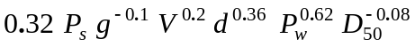 | 0.384 | 0.957
Froehlich Design (1988) |  | 0.433 | 1.540
HEC-18 | 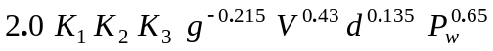 | 0.319 | 1.670
HEC-18/Mueller Equation (1996) | Where 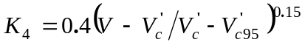 | 0.394 | 1.360

Table 5. Sensitivity analysis
Input combination | Input parameter removed | SVR
Input combination | Input parameter removed | RMSE (m) | R²
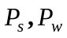, Skew, V, d,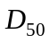 and  |  | 0.356 | 0.897
, Skew, V, d, and |  | 0.338 | 0.908
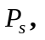Skew, V, d, and | 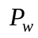 | 0.498 | 0.790
, Skew, V, and | d | 0.669 | 0.612
, Skew, V, d, |  | 0.340 | 0.904
, Skew, V, d, and |  | 0.410 | 0.859
, V, d, and | skew | 0.362 | 0.893
, Skew, d, and | V | 0.377 | 0.889

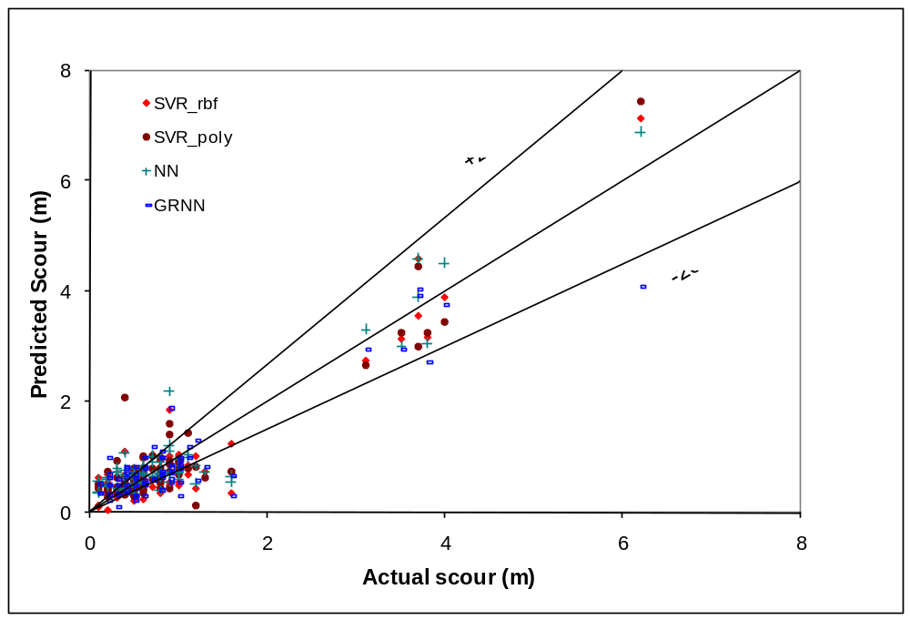 Figure 1. Actual vs. predicted scour using SVR, NN and GRNN.

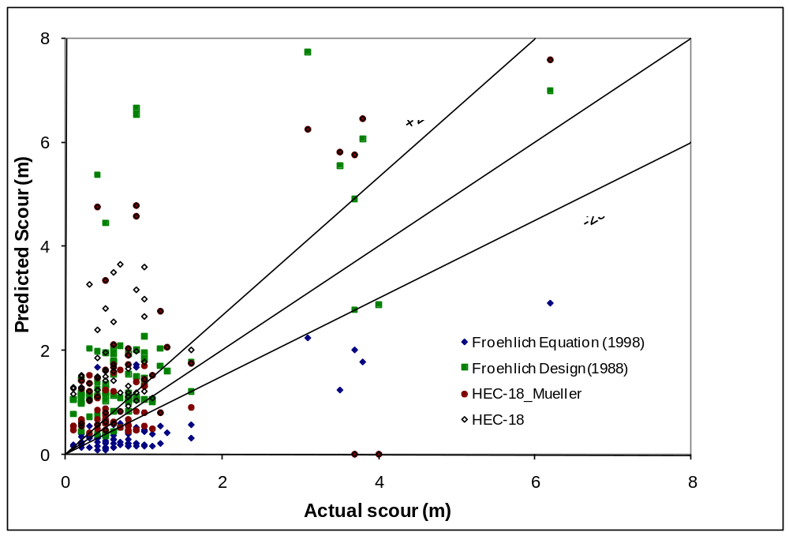 Figure 2. Actual vs. predicted scour using four empirical relations.

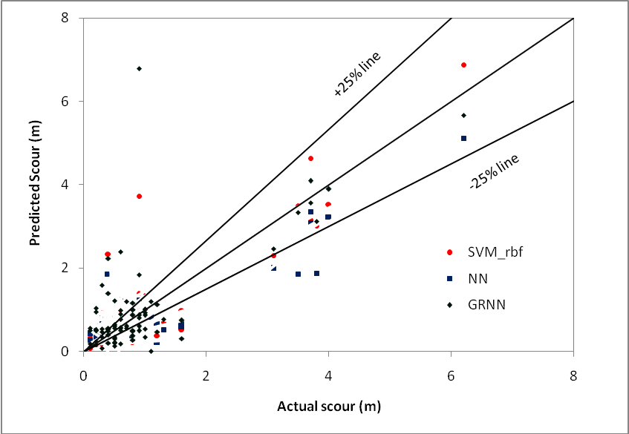
Figure 3. Actual vs. predicted scour using non-dimensional data.

Corresponding Author, Associate Professor, Department of Civil Engineering, NIT Kurukshetra, 136119, Haryana, India, mpce_pal@yahoo.co.uk. ²Assistant Professor, Department of Civil Engineering, BIT Meerut, 250103, India. Email: ernks2007@gmail.com. ? Assistant Professor, Department of Civil Engineering, NIT Kurukshetra, 136119, Haryana, India

